Software & Hardware Sizing Document

Microsoft® Office Enterprise Project Management Solution
Software & Hardware Sizing Document



AstroWix Corporation
39510 Paseo Padre Parkway, Suite 290, Fremont CA 94538, USA
Phone: +1 866 EPM OPM3, Fax: +1 510 791 1111
Email: info@astrowix.com



AstroWix India Project Solutions Pvt. Ltd.
Delhi NCR Office
A-53, Sector 16
Noida 201 301, INDIA
Phone: +91 120 431 5760, Fax: +91 120 431 5766
Email: info@astrowix.com
Bangalore Office
484, II Cross, 25th Main
BTM Layout II Stage
Bangalore - 560 076, INDIA
Phone: +91 80 2678 5916
Email: info@astrowix.com

Table of Contents

Introduction 4
Suggested 2-SERVER Architecture for Project Server 2007 4
Software required 4
Server 1 (Project Server) 4
Server 2 (Database Server) 4
Hardware required 5
Server 1 (Project Server) 5
Server 2 (Database Server) 5
Suggested 4-SERVER Architecture for Project Server 2007 6
Software required 6
Server 1&2 (Project Servers) 6
Server 3&4 (Database Server + Reporting Server) 6
Hardware required 7
Server 1&2 (Project Servers) 7
Server 3&4 (Database Server + Reporting Server) 7

Introduction
The purpose of this document is to provide specific Software & Hardware Specification required for Take Solutions

Suggested 2- Server Architecture for Project Server 2007

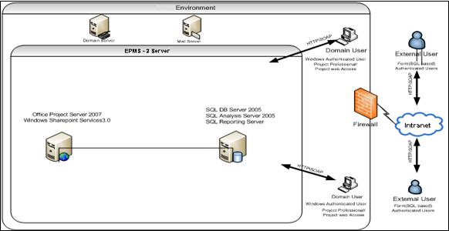

Software required
EPM Products | Licenses
Project Server 2007 SNGL OLP NL | 1
Project Server 2007 SNGL OLP NL CAL | 50
Project PRO 2007 SNGL OLP NL w1 Project Server CAL | 15
Media for project professional and Project Server (English) | 1
Operating System | Licenses
Windows Server Enterprise 2008 SNGL OLP NL | 2
Windows Server CAL 2008 SNGL OLP NL User CAL  (Equal to the total no of Project Pro + Project Server CAL) | 65
Media for Windows Server (English) | 1
Database | Licenses
SQL Server Enterprise 2005 SNGL OLP NL | 1
Media for SQL server (English) | 1

Team Assumption
Description
Project Size | 200 Activities
Projects | 50-100
Project Managers | 15
Team Members/Executives | 50
Concurrent User | 10-25

Hardware required

Server 1 (Project Server)
Hardware | Description
CPU | Quad-Core Xeon 2.0 GHz (64-bit Processors)
RAM | 8 GB
Disk | 100GB, C drive minimum 40GB
Network Cards | 100/1000 mbps recommended

Server 2 (Database Server)
Hardware | Description
CPU | Quad-Core Xeon 2.0 GHz (64-bit Processors)
RAM | 16 GB
Disk | 260 GB, C drive minimum 120 GB
Network Cards | 100/1000 mbps recommended

Suggested 4- Server Architecture for Project Server 2007

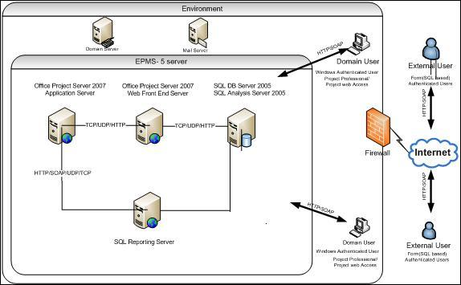

Software required
EPM Products | Licenses
Project Server 2007 SNGL OLP NL | 2
Project Server 2007 SNGL OLP NL CAL | 200
Project PRO 2007 SNGL OLP NL w1 Project Server CAL | 50
Media for project professional and Project Server (English) | 1
Operating System | Licenses
Windows Server Enterprise 2008 SNGL OLP NL | 4
Windows Server CAL 2008 SNGL OLP NL User CAL  (Equal to the total no of Project Pro + Project Server CAL) | 250
Media for Windows Server (English) | 1
Database (DB Server + Reporting Server) | Licenses
SQL Server Enterprise 2005 SNGL OLP NL | 2
Media for SQL server (English) | 1

Team Assumption
Description
Project Size | 500-1000 Activities
Projects | 200-500
Project Managers | 50
Team Members/Executives | 200
Concurrent User | 50-75

Hardware required

Server 1 & 2 (Project Server: 2 Nos.)
Hardware | Description
CPU | Quad-Core Xeon 2.0 GHz (64-bit Processors)
RAM | 8 GB
Disk | 100GB, C drive minimum 40GB
Network Cards | 100/1000 mbps recommended

Server 3 (Database Server)
Hardware | Description
CPU | Quad-Core Xeon 2.0 GHz (64-bit Processors)
RAM | 16 GB
Disk | 260 GB, C drive minimum 120 GB
Network Cards | 100/1000 mbps recommended

Server 4 (Reporting Server)
Hardware | Description
CPU | Quad-Core Xeon 2.0 GHz (64-bit Processors)
RAM | 8 GB
Disk | 100 GB, C drive minimum 40 GB
Network Cards | 100/1000 mbps recommended

